Masari Outreach: Getting to Know the GUI Wallet

This educational activity is designed to show the new user how to use the Graphical User Interface (GUI) Wallet.

Download the Official Masari Wallet

To start, you will need the official Masari wallet from getmasari.org. You may pick from any operating system but be sure to select the GUI wallet and not the CLI wallet.

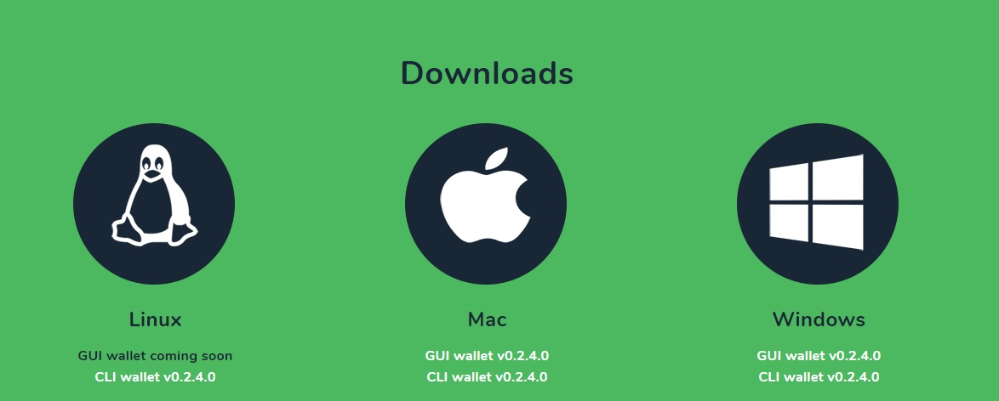

Open the Masari Wallet

Once you have downloaded the Masari wallet, you may double click it to open it. It will prompt you to select a language. To select a language, simply double click your country’s flag.



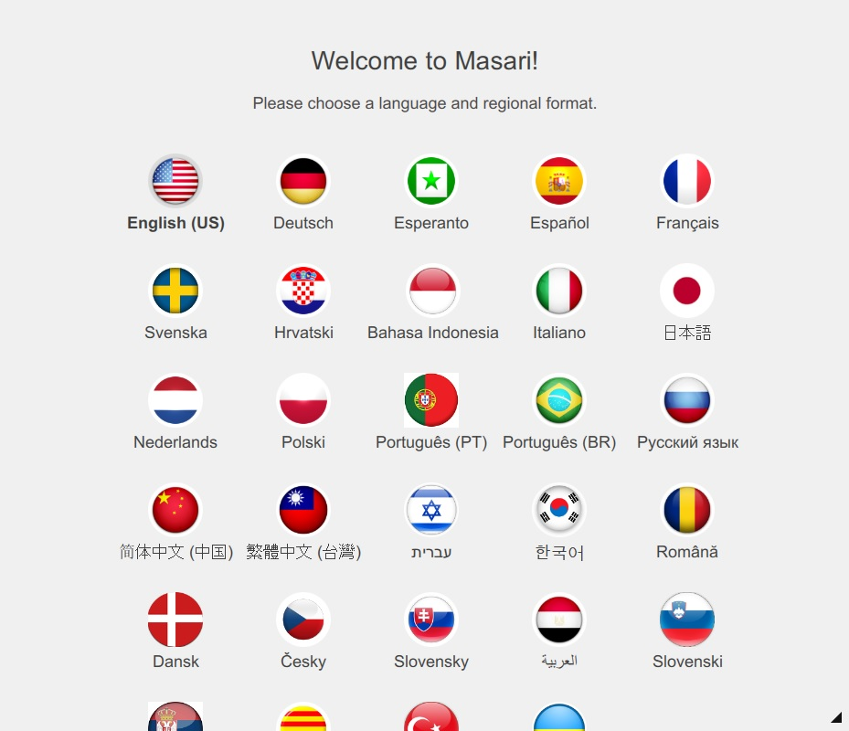

Setting Up Your Wallet

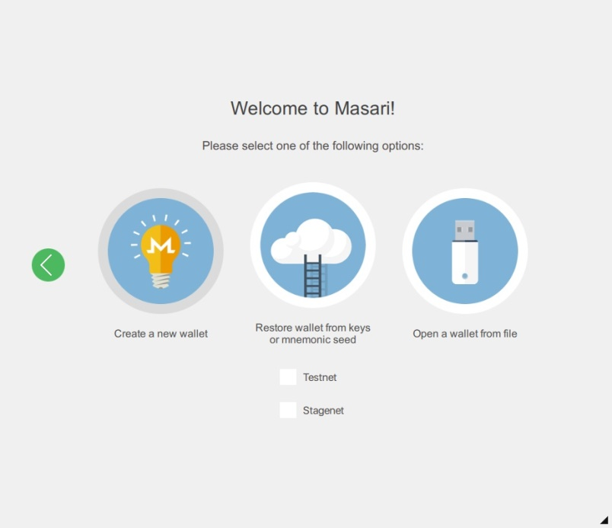Once you have picked your language, you can create a new wallet. When you click this icon, you will be given a mnemonic seed. This list of words is what is used to restore your wallet if you ever lose it or forget the password. So long as you remember and store this key, you will have access to your funds. It is advised for you not to simply remember this phrase in your head but instead write it down and store it in a secure place.

Choosing a Password

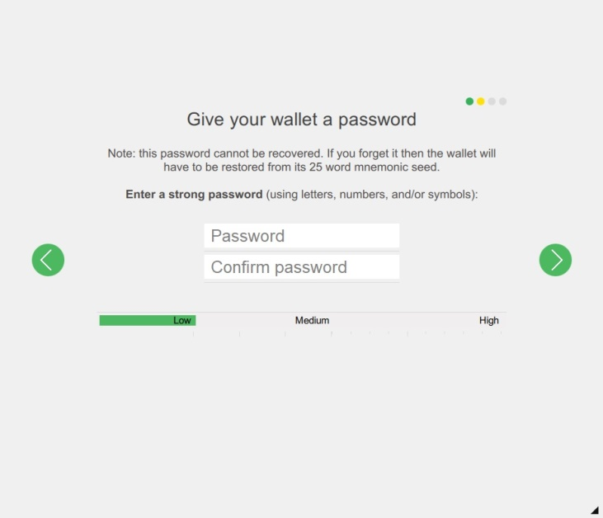You may now choose a password for your wallet. When you do this, it is advisable to pick a password that is complex and not simply “`12345” as you could lose your funds if a malevolent person logs into your wallet.

Daemon Settings

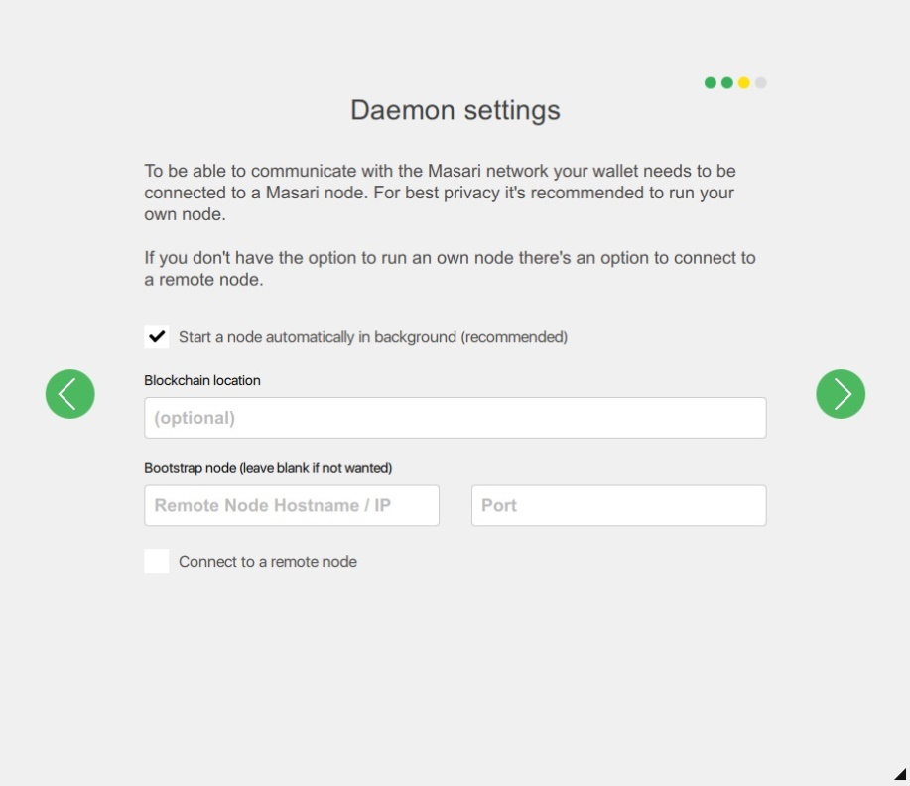When you have chosen your password, the wallet will then ask you what kind of Daemon settings you wish to have. The easiest way for your wallet to connect to the blockchain is by selecting the default status of “starting a node in the background.” It may take a while for you to synchronize with the network with this selection and your computer may slow, however, this is normal and you have no need to worry. Faster computers will generally not slow much.



Using Masari

The GUI wallet is designed to give you the simplest experience using Masari. This being the case, sending and receiving Masari is a snap!

Synchronizing

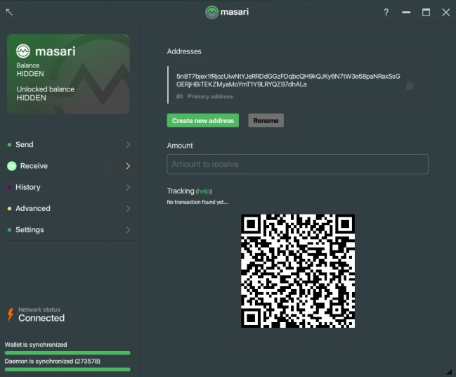The first thing you must do when using your wallet is wait for the daemon to synchronize to the network. You can see progress in the bottom left of the wallet. When you are synchronized, the daemon will inform you that you may now use Masari.

Sending Funds

To send funds, all you need to do is click the send tab on the left of the wallet and then enter the amount of Masari you wish to send in the “Amount” field. Keep your “Transaction Priority” at default for most transactions. Lastly, enter in the payment address in the “Address Field” and then click “Send” to send your funds to your recipient.

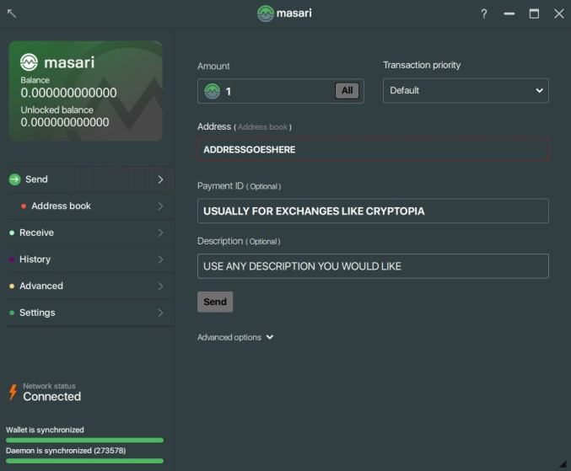*Note: in some cases you may be required to enter in a payment ID to send your funds successfully. This feature is mostly relegated to exchanges such as Cryptopia. If you do not include the payment address that they provide you, you will lose your funds!*

Receiving Funds

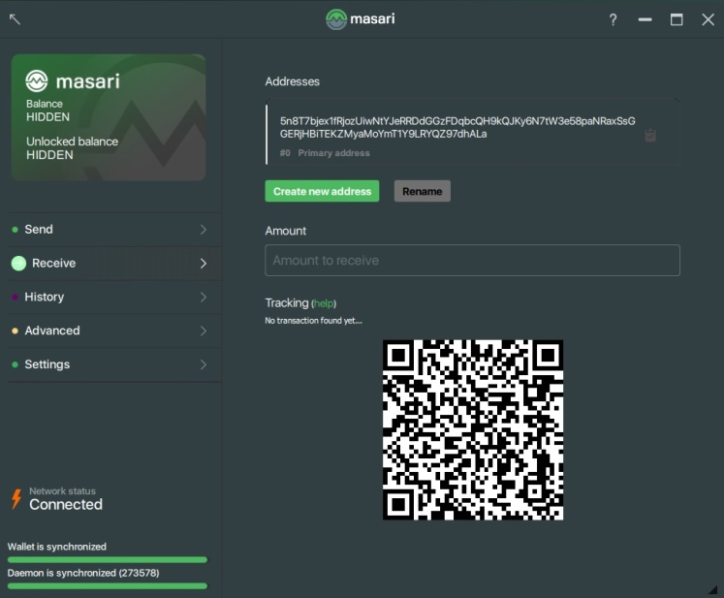To receive funds, simply click on the “Receive” tab on the left. When you do this, you will see an address that starts with a “5.” You can click the clipboard on the right of the address to automatically copy the address to your computer’s clipboard. The QR code on this screen is a visual representation of your address, copy this QR to signs and cards to receive funds in your physical store.

Looking at Your History

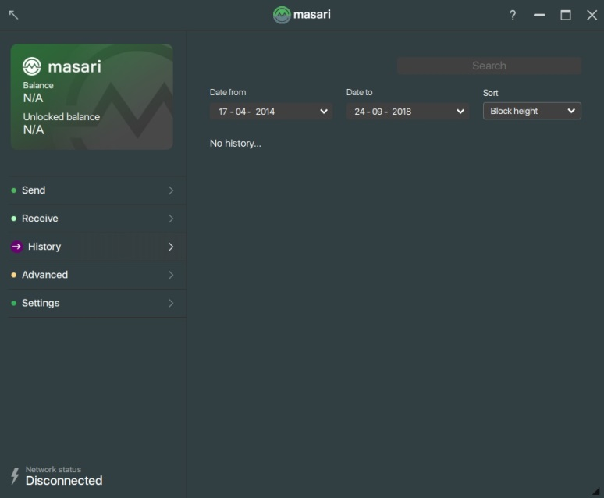If you want to see your transaction history, all you need to do is click on the “History” tab of the wallet. From there, you will be able to see a history of all of your purchases and notes. You will also be able to see if all of your notes you have added to each transaction.

Checking Your Seed

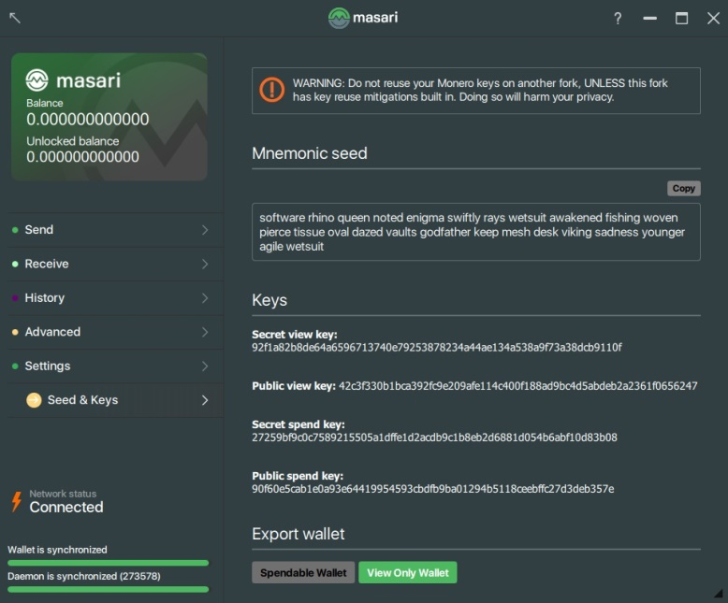You can see your mnemonic seed again by checking the “Settings” tab and selecting “Seed & Keys.” When you do this, you will be prompted to type your password again. From there, you will be able to see your mnemonic seed as well as your secret keys. Do not share this information with anybody. Ever.

This concludes the Masari wallet activity. Enjoy having Masari readily available on your desktop. If you ever have any questions, look for help at the communities below. Somebody will always be available to help you.

Online Communities

[BitcoinTalk](https://bitcointalk.org/index.php?topic=2159114)

[r/masari](https://www.reddit.com/r/masari/)

[Twitter @masaricurrency](https://twitter.com/masaricurrency?lang=en)

[Discord](https://discord.gg/sMCwMqs)

[Telegram](https://t.me/masaricurrency)

[Forum](https://forum.getmasari.org/)